ORDER OF WORSHIP
* Indicates, please stand if able.
First Sunday after the Epiphany January 7, 2024 9 am
Liturgist: Tom Epps

WELCOME, PASSING THE PEACE OF CHRIST, & ANNOUNCEMENTS
*CALL TO WORSHIP
L: In the beginning, God…
P: Swept over waters, spoke light into existence, created day and night and called it good.
L: As the days and nights of creation filled with life, God…
P: Made humanity out of the dirt to love and tend creation, to be loved and tended by God.
L: As we lost our way, God…
P: Sent Jesus, Love Incarnate, to show us the way back.
L: On the day Jesus came to the banks of the Jordan River to be baptized, God…
P: Declared, “You are my Son, the Beloved; with you I am well pleased.”
L: Let us, then, follow Jesus into the waters, remembering our baptism in which God…
P: Claims us as beloved children, the family of God.
*OPENING PRAYER (Genesis 1, Psalm 29)
God of power and majesty, you call forth creation, acting with strength and power.
We praise you, as we stand in awe of your glory. You are mighty and powerful, and yet you care for us, pouring your Spirit of love upon us, recreating us for your work in the world.
You are at work in our midst, offering a new day of hope and possibility. Open our hearts to the sound of your voice. Send the power of your Spirit among us, that we might become agents of your love and peace. Amen.
*OPENING HYMN We Three Kings UMH #254
CHILDREN'S TIME
INTRODUCTION TO NEW LEADERSHIP
JOYS AND CONCERNS

PRAYER OF CONFESSION (Genesis 1, Mark 1)
God, we are so tired. The holidays were a wonderful, busy time, as we celebrated the birth of Jesus. As we return to life without festive celebrations, we long to avoid feeling let down or discouraged. Teach us to listen for your gentle voice. Help us awaken to the quiet stirrings of new life in our hearts and in our communities. As your children, called into being by your word, remake and renew us, that we may follow you with joy. Amen.
WORDS OF ASSURANCE (Mark 1)
You are God’s child, God’s beloved creation. Receive God’s offer of new life and new beginnings.
PASTORAL PRAYER Rev. Shon
THE LORD’S PRAYER (In Unison)
INVITATION TO THE OFFERING (Genesis 1, Psalm 29)
Over and over, God’s creating Spirit blows through our lives. In our giving, we respond to this Spirit.
*DOXOLOGY Praise God, from Whom All Blessings Flow UMH #94
*OFFERTORY PRAYER Rev. Shon
SCRIPTURE Matthew 6:25-34
²⁵ “Therefore I tell you, do not worry about your life, what you will eat or drink; or about your body, what you will wear. Is not life more than food, and the body more than clothes? ²⁶ Look at the birds of the air; they do not sow or reap or store away in barns, and yet your heavenly Father feeds them. Are you not much more valuable than they? ²⁷ Can any one of you by worrying add a single hour to your life?
²⁸ “And why do you worry about clothes? See how the flowers of the field grow. They do not labor or spin. ²⁹ Yet I tell you that not even Solomon in all his splendor was dressed like one of these. ³⁰ If that is how God clothes the grass of the field, which is here today and tomorrow is thrown into the fire, will he not much more clothe you—you of little faith? ³¹ So do not worry, saying, ‘What shall we eat?’ or ‘What shall we drink?’ or ‘What shall we wear?’ ³² For the pagans run after all these things, and your heavenly Father knows that you need them. ³³ But seek first his kingdom and his righteousness, and all these things will be given to you as well. ³⁴ Therefore do not worry about tomorrow, for tomorrow will worry about itself. Each day has enough trouble of its own.

*HYMN OF PRAISE The Snow Lay on the Ground TFWS #2093

SERMON Seek First His kingdom and His Righteousness Rev. Shon
COMMUNION UMH #12-15
*CLOSING HYMN Seek Ye First UMH #405
*BENEDICTION Rev. Shon

ANNOUNCEMENTS
PRAYER REQUESTS: Please pray for people in need in our church, community, nation,
and the World.
MORNING PRAYER: Every morning from 7 to 8 am with Disciplines by Upper Room.
PRAYER WORKSHOP: January 18th and 25th at 6 pm. We will learn 4 forms of Prayer life based on your personality type.
STEWARDSHIP CAMPAIGN: for the upgrade of the sound and video system at the
Sanctuary, boilers replacement, and next year’s church budget.
DINNER CHURCH: We will meet on Wednesday, Jan. 10th, at 5:30 pm. Team members
wanted.
NEW MEMBER CLASS: January 14th, 21st, and 28th. WELCOME new members!
SEWING GROUP: January 17th, 10 to 3:00 pm. Sewing Pillowcase Dresses. Double-fold bias tape (all colors) and gently used or new cotton pillowcases are needed.
SPRC Training: Sat., Jan. 27, 9:30 am – 12:30 pm, Wisconsin Rapids UMC,
Sun., Feb. 4, 3 pm -6 pm, BRFUMC
USHER/GREETERS: Pat and Diane Moe
FELLOWSHIP: Esther Shon

UPCOMING MEETINGS

Mon Jan. 8 Trustees 5:00 pm
Tue Jan. 9 Worship Comm. 5:30 pm
Tue Jan. 9 Finance Committee 5:30 pm
Wed Jan. 10 Dinner Church 5:00 pm
Wed Jan. 10 Youth/Confirmation 5:30/7 pm

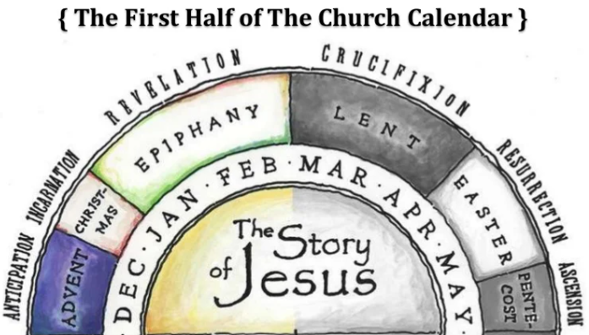

BLACK RIVER FALLS
UNITED METHODIST CHURCH

UMC Mission Statement:
"To make disciples of Jesus Christ for the transformation of the world.”

PASTOR Rev. Inwha Shon
PIANIST Joyce Moldenhauer

100 North Fourth Street, Black River Falls, WI. 54615
Phone: 715-284-4114 Office Hours: Monday-Thursday, 9 am-2 pm
Website: brfumc.org YouTube: brfumc
Facebook: Black River Falls United Methodist Church

